Experiment worksheet

2.6 Energy flows through an ecosystem

Pages 28–29 and 186

Challenge 2.6: Food for thought

What you need

* 1 L bottle of coloured water
* 10 mL and 100 mL measuring cylinders
* Plastic cups (4 for each organism)
* Dropper

What to do

1 Work in groups of five to represent five different parts of the food chain: the Sun, native grass (producer), a cricket (herbivore), a wedge-tailed eagle-hawk (top consumer), and a fungus (decomposer).

2 Use the bottle of coloured water to represent the Sun’s energy. The total energy available from the Sun is equal to the volume in the bottle (i.e. 1000 mL).

3 Give a cup to each person representing a part of the food chain.

4 Through photosynthesis, the plant receives 6% of the solar energy available to it:   
6% of 1000 mL = 60 mL. Measure and pour 60 mL of coloured water into the plant’s cup.

5 The herbivore receives 10% of the energy: 10% of 60 mL = 6 mL. Measure out 6 mL from the plant’s cup and pour this into the herbivore’s cup.

6 The top consumer receives 10% of this energy: 10% of 6 mL = 0.6 mL. Measure out 0.6 mL from the herbivore’s cup and pour this into the top consumer’s cup.

7 When the top consumer dies, the decomposer will get 10% of its energy: 10% of 0.6 mL = 0.06 mL. This can be represented by adding a single drop into the decomposer’s cup.

Discussion

1 Which organism would have been ‘most satisfied’ by the amount of energy/food it received? Which would have been least satisfied?

2 Explain what has happened to the 1940 mL of ‘energy’ from the Sun that did not pass into the plant.

3 How much ‘energy’ did the herbivore receive? How was 90% of that used by the insect (cricket)?

4 Which consumer in the food chain will have to find the most food to gain enough energy to survive? Explain your answer.

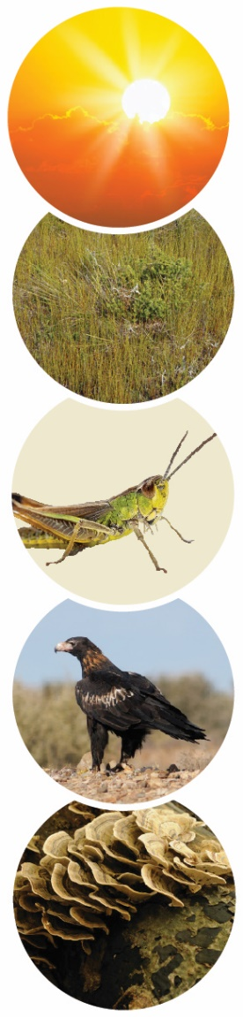

**FIGURE 1**